**APPLICATION OF TECHNOLOGY OF INTERNET OF THINGS IN POWER ENGINEERING FOR IMPLEMENTATION OF OPERATIONAL MONITORING OF DAMAGES IN LOW VOLTAGE ELECTRICAL NETWORKS FOR ESTIMATE TECHNICAL CONDITION OF EQUIPMENT AND CONTROLLING OF RELIABILITY OF POWER DISTRIBUTION ENERGY SYSTEM**

E.A. Voloshin, A. A. Voloshin, S. S. Usachev, A.R. Ententeev

Relay Protection and Automation of Power Systems Department, National Research University «MPEI», Moscow, Russia

E-mail: [usachevproject@gmail.com](mailto:usachevproject@gmail.com)

**Introduction**

In some cases, there is a need for monitoring low-voltage systems with subsequent conservation and systematization of measurements. In conditions of low-level for monitoring energy distribution systems, the use of new technologies based on algorithms of Internet of things, can reduce the costs of maintenance of electrical networks or power distribution systems. During the research, the technology of the Internet of things was used, where the microcontroller ESP8266 and the ACS712 current sensor module were used as a basis for the developed measuring instrument. As a result, we have a constructive solution of the portable meter, allowing measuring the current value in electrical networks with the subsequent systematization of the received information and sending it to a dedicated server. An algorithm for the working of device in the technology of the Internet of things has been obtained. The developed measuring instrument and derived algorithms of network can be used to improve the quality of monitoring in electricity distribution systems, for estimate technical condition of equipment and controlling of reliability of power distribution energy system

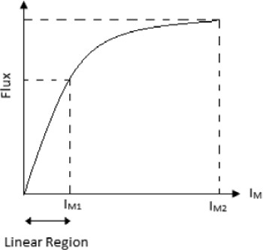

Figure 1 - Magnetization curve of current transformer

Table 1

|  |  |  |  |  |
| --- | --- | --- | --- | --- |
| Example | Example | Example | Example | Example |
| Example | Example | Example | Example | Example |
| Example | Example | Example | Example | Example |
| Example | Example | Example | Example | Example |

## **References**

1. A.G. Phadke and J.S. Thorp, Synchronized Phasor Measurements and Their Ap- plications, 2nd ed. New York: Springer, 2017, p. 285.
2. IEEE/IEC International Standard - Measuring relays and protection equipment - Part 118-1: Synchrophasor for power systems - Measurements,” in IEC/IEEE 60255-118-1:2018, pp. 1–78, 19 Dec. 2018.